When the Melody Plays, the Hero Within Never Fades

Do you remember the first time you heard the Superman theme? That soaring melody seemed to pierce through the screen, making us believe that there truly were extraterrestrial heroes capable of flying anywhere at a moment's notice to battle villains. Batman’s opening score, dark and commanding, uses every note to narrate the Dark Knight’s unwavering resolve to protect his city. These opening themes are far more than just background music; they are the emotional anchors of our generation, carrying our childhood dreams of protecting those we love.

However, as we transition into adulthood, the relentless cycle of work, commutes, and bills gradually erodes that yearning for the omnipotent hero. We grow accustomed to the mundane, to compromise, and to locking our "save the world" dreams deep within our memories. Yet, in the quiet of the night, if you happen to catch those familiar chords, does a flicker of excitement still stir in your heart? That youth who once believed they could change the world has never truly left.

The truth is, every life deserves a unique theme song. Though we weren't born as Supermen destined to save the planet, we fight our own battles every single day—overcoming fears, breaking through plateaus, and guarding those we hold dear. These seemingly ordinary moments constitute the most moving chapters of our personal epics. But how do we translate these internal tides into a musical language that can be heard and felt? Traditional music composition requires years of professional training, mastering complex skills like music theory, orchestration, and recording—a barrier that has kept the gates of the musical temple closed to most.

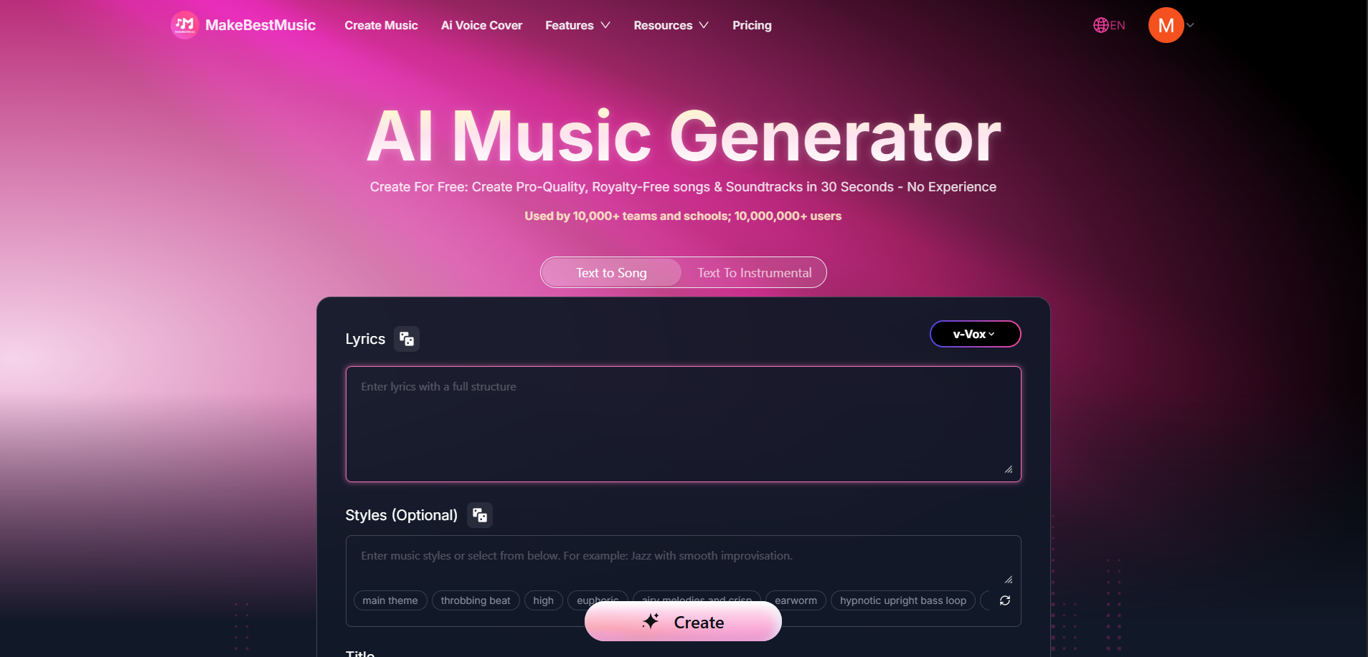

But today, in 2026, the latest Artificial Intelligence technology is redefining the possibilities of musical creation. AI is not here to replace human emotional expression; instead, it serves as a seamless bridge. Acting as a master translator, it can parse the emotional intent you describe in words and translate it into the fundamental elements of music: harmony, rhythm, and melody. Through the precise weaving of algorithms, it generates a complete work with genuine artistic resonance. This process puts technology at the service of emotion, allowing everyone to transcend professional barriers and score their life stories with the soundtracks they deserve.

A Three-Step Guide: Composing Your Exclusive Soundtrack with MakeBestMusic

When using music to carry precious emotions, we need more than just a tool; we need a partner that understands our thoughts and accompanies us through the entire creative journey. MakeBestMusic is exactly that—a high-tech, high-energy AI music production platform. Through its clear modular design, it helps you deconstruct the complex music production process into transparent, intuitive, natural language operations. This allows you to focus on expressing your emotions and concepts rather than struggling with technical musical details.

Step 1: Let the AI Lyric Writer Be Your Storyteller

We all carry a rough draft of a story about courage and love: a tale of an ordinary person facing life’s hardships, standing up time and again, and finally finding their own strength. This story might stem from your personal experiences or a profound realization from a specific moment. However, not everyone is a natural-born lyricist. How do we transform these abstract emotions into rich, structured, and singable lyrics? This is exactly where the AI Lyric Writer comes in.

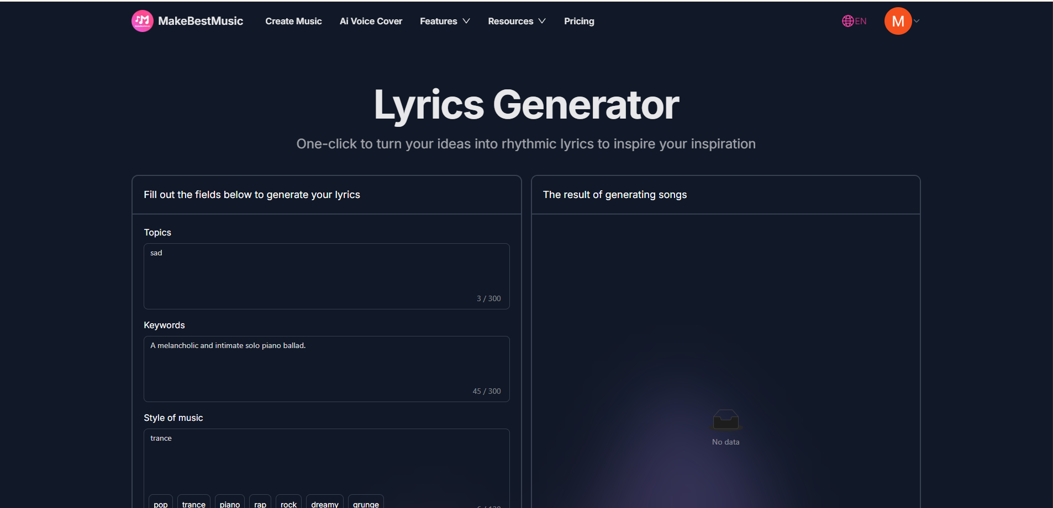

In MakeBestMusic’s "Create Music" feature, you can select "Custom Mode" to gain full creative control. When you click the "AI Lyrics" button, the system generates structured lyrics based on the story outline and emotional tone you provide. This isn't a simple word-mash; it’s based on deep learning from countless classic lyrical works. The AI understands which words belong in the Verse to build the narrative and which expressions should be placed in the Chorus to amplify the emotional climax.

For example, when you enter a simple description like "A superhero story about overcoming fear and reclaiming courage," the AI will generate a complete lyrical structure including an introduction, development, climax, and resolution. You can edit the results to make certain phrases more personal. This makes the creative process controllable: you enjoy the efficiency of AI while retaining ultimate authority over the work. It allows those who struggle with words to convey their feelings accurately; you don’t need to be a poet—you need to describe your intent honestly, and the AI will find the perfect linguistic vessel for you.

Step 2: Shape Your Sound with Style Descriptions and References

Now that we have structured, singable lyrics, the next critical question is: What should this song sound like? Should it have the epic grandeur of a Hans Zimmer score for Batman, or lean closer to the synth-heavy retro vibe of an 80s superhero cartoon?

To help the AI fully and accurately understand and realize your vision, you need to describe your desired musical style in as much detail as possible in the "Styles" configuration area. First, click "Create Music" in the top left of the homepage, open the main workstation, select "Custom Mode," and find the "Style" box—this is where our magic happens.

In the style box, you can describe specific requirements, including: Music Genre (e.g., Epic Orchestral, Synth-pop), Tempo (e.g., 120 BPM), Core Instrumentation (e.g., "Soaring string section," "Thundering timpani"), and Vocal Type (e.g., "Male vocal with heroic tone"). We can also use MakeBestMusic’s Meta Tags to define a clear song structure, helping the AI generate a work that aligns perfectly with your arrangement needs.

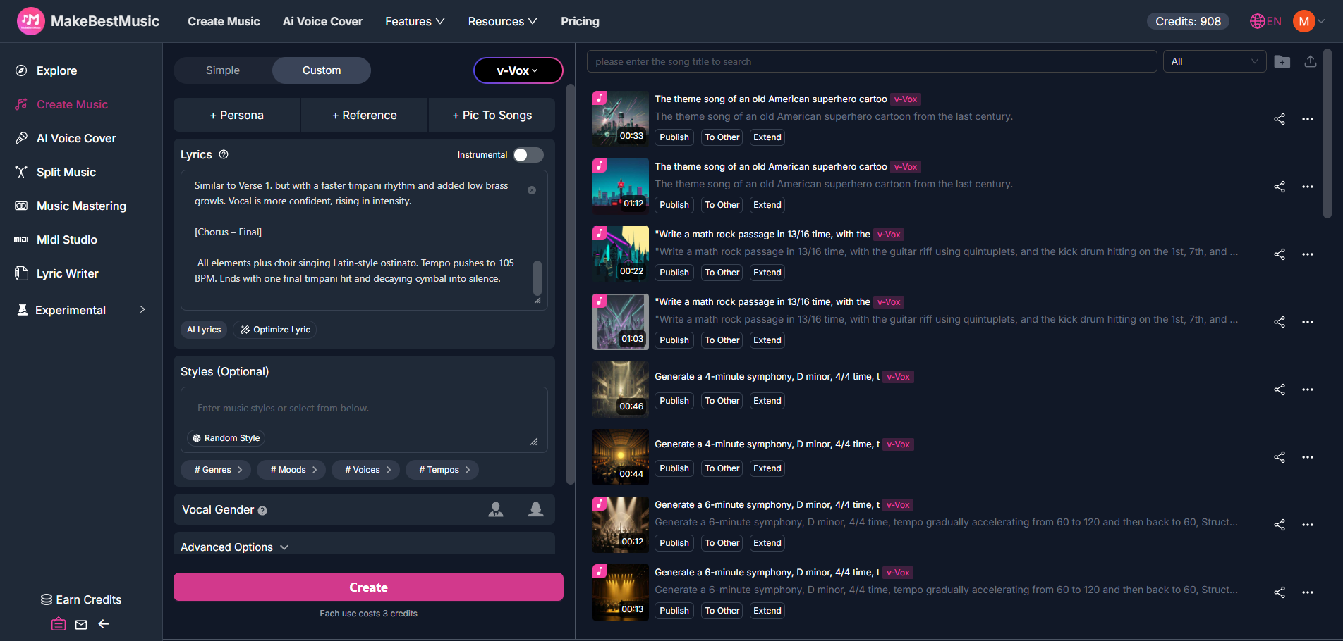

To let you test this yourself, we have prepared a tested prompt with clear structural markings and musical descriptions. Try entering this into the style box and listen to the result!

A dark, powerful epic orchestral track in D minor, 4/4 time, 90 BPM, rising to 105 BPM. The [Intro] features a lone piano repeating a single heartbeat note and deep pulsating low strings, creating a tense, atmospheric build. In [Verse 1], sparse marching timpani strikes and a dark cello countermelody support a gritty, determined male vocal, with minimal brass stabs at phrase ends. The [Chorus] explodes with a full orchestra: heroic D-minor brass fanfare, thundering timpani on every quarter note, soaring strings, and distant organ pedal tones, while the vocal belts with reverb-soaked power. The [Verse 2] returns to the verse pattern but adds low brass growls and a faster timpani rhythm, with the vocal becoming more confident. The [Final Chorus] brings in a Latin-style choir ostinato and pushes the tempo to 105 BPM, ending with a single final timpani hit and decaying cymbal into silence.

If these professional terms feel foreign, MakeBestMusic offers a more intuitive solution—the "Reference" feature. You can upload a superhero theme you love as a reference audio file. The system will analyze the song's style characteristics, instrumentation, and rhythmic patterns, then draw upon these elements when generating your new work. The beauty of this feature is that it isn't a simple copy; it extracts the "style genes" and combines them with your lyrics and additional descriptions to create a completely original song that captures the spirit of your favorite tracks.

This approach allows you to "stand on the shoulders of giants." You don’t need to figure out which instruments express heroism from scratch; you just find a reference that feels "exactly right," and the AI helps you recreate that feeling. It significantly shortens the distance from idea to finished product, making creation efficient and predictable.

Step 3: Perform Your Heroic Tale with Your Own Voice

Once the lyrics and music are ready, the final question is: Who will sing it? For most, professional recording equipment and vocal techniques are insurmountable hurdles. But what if I told you that you could sing this song yourself without worrying about pitch, technique, or recording quality?

MakeBestMusic’s "AI Voice Cover" feature achieves this seemingly impossible goal. Powered by AI Singing technology, it extracts the unique timbre of your voice and uses it to perform the vocal track of any song while maintaining professional-grade pitch and expressiveness.

Here is the step-by-step process:

- Create a "Persona": Select the "AI Voice Cover" menu on the left sidebar, then "Select Voice" to open the voice cloning panel. Click "Clone My Voice" and upload a recording of yourself singing a cappella. It doesn't need to be long—30 to 60 seconds is enough—but ensure the audio is clear without background noise. The system analyzes your voice’s frequency, resonance, and texture to build your exclusive voice model.

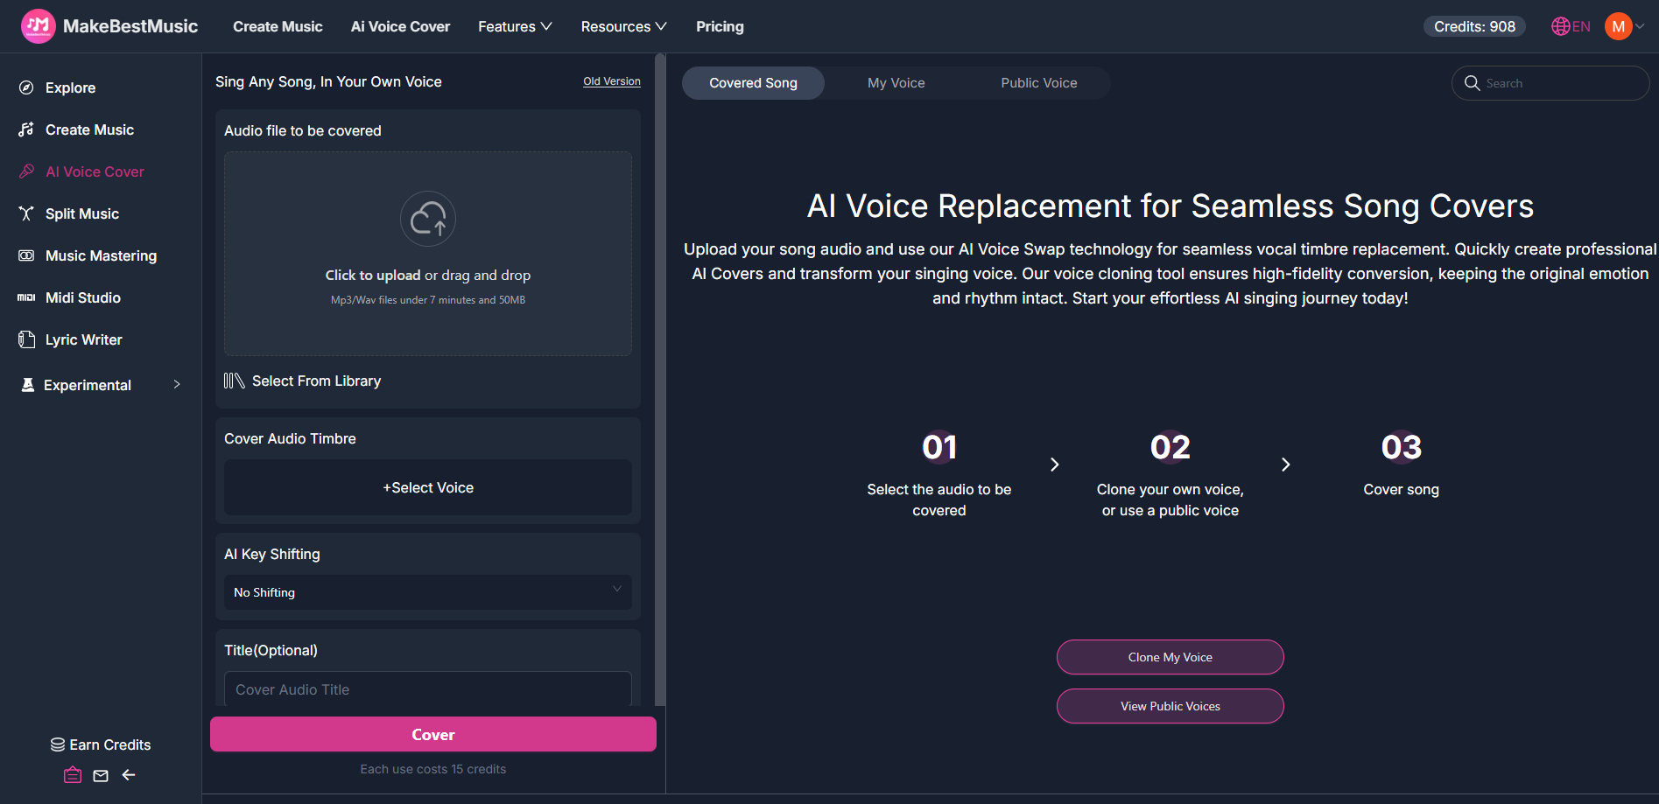

- Cloning Fidelity: You can choose different precision levels. "High-Fidelity" and "Premium" modes perform deeper analysis, including the automatic removal of auto-tune effects and background noise from your recording, ensuring the AI captures your most natural and authentic voice.

The Final Performance: Once the model is ready, you can "personally" sing your superhero theme. Return to the AI Voice Cover interface, select your new "Persona" in Cover Audio Timbre, and select your generated music from the Library. Click "Cover," and the system will apply your voice to the vocal track. The result sounds like a professional studio recording performed by you. This preserves your vocal identity while utilizing AI to ensure the pitch, rhythm, and emotional delivery are top-tier.

This feature successfully decouples "talent" and "vocal quality" from "professional skills." You don’t need to be a trained singer to deliver a performance full of heart. When you hear your own voice singing your heroic theme, that sense of "this is my story" is an immersion that no other singer could replicate.

FAQ

1. I prefer old-school superhero anime themes over modern blockbuster scores. Can the AI generate those?

Absolutely. MakeBestMusic supports musical styles spanning from the 20th century to the present day. If you miss the synth-pop and electronic drum vibes of 80s classics like Transformers or Mobile Suit Gundam, you can specify this in your style description: "80s anime opening theme, synth-pop, analog synthesizer, electronic drums, energetic tempo."

Furthermore, you can use the Reference feature to upload an old anime theme. The system will analyze the era-specific sound processing and melodic trends to recreate that retro aesthetic. You can even increase the "Audio Influence" parameter in "Advanced Options" to stay closer to that Golden Age sound.

2. I have some original hero stories, but I can't write lyrics. Can AI help?

This is exactly what the AI Lyric Writer is designed for. You need zero songwriting experience—just the ability to describe your story in your own words. In "Custom Mode," click the "AI Lyrics" button and input your story outline. Based on your description, the AI will build a complete structure: building the background in the Verse, creating conflict in the Pre-Chorus, amplifying the theme in the Chorus, and providing an emotional pivot in the Bridge. The resulting lyrics will use imagery and metaphors consistent with the superhero genre while staying true to your original narrative.

3. Can I share these on streaming and social media platforms without legal risks?

This is a crucial question. The copyright of works generated by MakeBestMusic depends on your source material. If you use entirely AI-generated lyrics, melodies, and arrangements—using either your cloned voice or the platform’s public models—the work is considered original, and you hold full usage rights to share or upload it to streaming services.

However, if you use the "Reference" feature with a copyrighted commercial song, the output might contain elements similar to the original. While AI performs a creative transformation, high similarity can still lead to copyright issues.

- For personal/non-commercial use: You can use any reference; just credit the inspiration (e.g., "Inspired by [Original Track Name]").

- For commercial/streaming use: We recommend using your own original audio as a reference, using public domain music, or lowering the "Audio Influence" parameter to ensure originality.

4. Can MakeBestMusic create superhero-style background music (BGM) without vocals?

Definitely. The "Instrumental" mode is dedicated to pure music. In "Custom Mode," toggle the "Instrumental" switch to ON, then describe your BGM style in the "Styles" config. If you need a longer track, use the "Extend Music" feature. It analyzes the style and structure of your generated clip and intelligently writes new sections with natural transitions. By using "Extend" multiple times, you can create a full background track lasting several minutes.

Conclusion: When the Music Starts, You Are Your Own Superhero

We’ve spent a lot of time discussing technology, features, and workflows, but what truly matters is that feeling you get when you first hear your own voice singing a song that tells your story. In that moment, you realize that your life is profoundly worthy of being recorded and felt. The persistence that felt insignificant, the struggles no one saw, and the moments of quiet sacrifice—all of it deserves to be celebrated. You don’t need to save the world, because you save yourself every day: from inertia, from fear, and from compromising with mediocrity.

This theme song will become an anchor in your life: a reminder of your courage when you’re tired, a guide to your original path when you’re lost, and a witness to your growth when you succeed.

Now, open MakeBestMusic and turn the story in your heart into a melody. Let AI help you cross the technical threshold, and let music become the vessel for your soul. Because everyone deserves their own theme song, and everyone is the superhero of their own life.

The moment the music starts, you will realize: the hero was never absent, because you were there all along.

